Name:   
Project Name:

Supervised By:

Index

Introduction ……………….……………….…………….……………….……………….……………….……………….……….3

Entities ……………….…………………….……………….……………….……………….……………….…………………………3

Repositories ……………….……………….……………………….……………….……………….……………….………………4

Controllers ……………….…………………….……………….……………….……………….……………….……………………5

Surpassing the expectations ……….………………….……………….………….…….……………….……………………7

Introduction

This is a simple ticket reservation system for football world cup, from this system you can reserve a chair in the stadium.

We have 3 roles

Admin: verify users – delete users – see some statistics of system

Manager: create matches

Fan: see coming matches – reserve ticket – edit profile

**Entities**

[**Repositories**](reservation/src/main/java/com/world_cup/reservation/repositories/UserRepository.java)

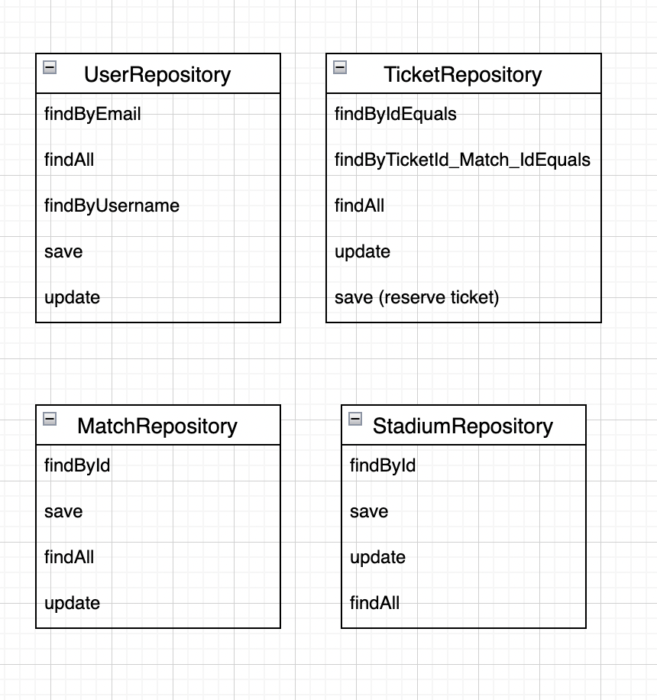

**Controllers**

**Surpassing the expectations**

* Additional generated queries
* Additional native queries (@Query)
* Complex queries (Join,)



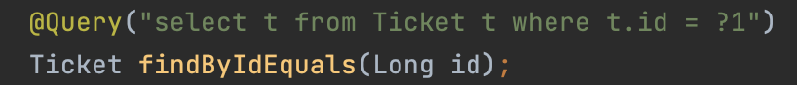

* Additional endpoints
* Use of different Methods (GET, POST, PUT, DELETE, ...)

I used more than expected end points in controllers

* Use of additional libraries

1. Lombok (default getter and setter)
2. Auth (for authentications)
3. Spring doc (for swagger controllers)

* Security (Authentication, Access Control, ...)

